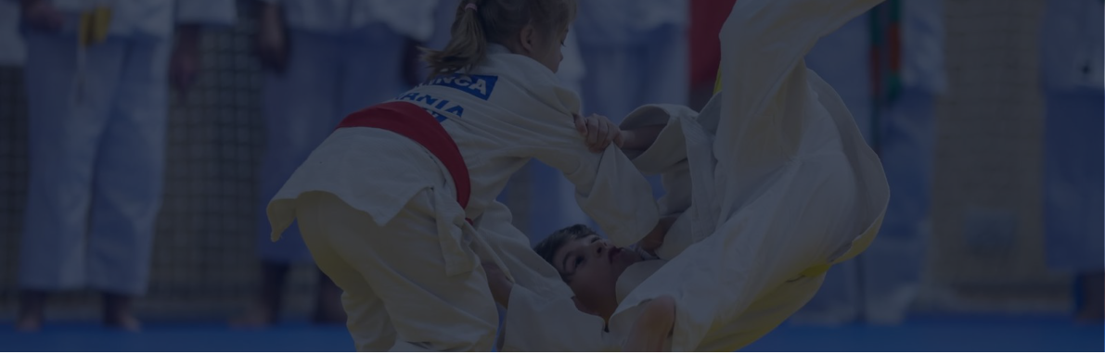
REGISTRATION FORM
JUDO WITHOUT BARRIERS 2026
23-25 October 2026 • Bacău • Narcisa Lecușanu Sports Hall
Send registrations via WhatsApp: Cătălina - +40 772 172 745
Complete all applicable fields and check that the categories are correct before submitting.

1 CLUB AND DELEGATION DETAILS

Full club name | Town / country

Coach / head of delegation | Phone | E-mail

Billing details: name, tax identification number, address

2 DELEGATION SIZE AND PARTICIPATION

No. of athletes | No. of coaches | No. of accompanying persons | Total delegation

☐ Individual competition | ☐ U16 teams | ☐ U18 teams | ☐ Individual + teams

3 ARRIVAL, ACCOMMODATION AND MEALS

Arrival date and time | Means of transport | Arrival notes

☐ Accommodation required | ☐ No accommodation required
No. of persons | No. of nights | Rooms

☐ Meals required | ☐ No meals required
No. of persons | Allergies / dietary requirements

Additional accommodation and meal information

4 FEES AND USEFUL INFORMATION

Individual entry fee: RON 100 / competitor / category Team entry fee: RON 500 / team
Accommodation / meals: Gabriela +40 791 577 044 / Raluca +40 747 832 795 • Rules: Remus +40 760 677 977 / Simona +40 739 000 440

JUDO WITHOUT BARRIERS 2026
INDIVIDUAL ENTRIES - ATHLETE LIST
International tournament | 23-25 October 2026 | Bacău, Narcisa Lecușanu Sports Hall
Page 2 / 5
Enter one athlete per row. Age groups and weight categories must match the official invitation.
No. | Full name | Birth year | Sex | Age group | Cat. (kg) | Weight (kg) | Licence / notes
1
2
3
4
5
6
7
8
9
10
11
12
13
14
15
16
17
18
19
20
21
22
23
24
25
26

JUDO WITHOUT BARRIERS 2026
INDIVIDUAL ENTRIES - ATHLETE LIST
International tournament | 23-25 October 2026 | Bacău, Narcisa Lecușanu Sports Hall
Page 3 / 5
Individual entries continued - athletes no. 27-52.
No. | Full name | Birth year | Sex | Age group | Cat. (kg) | Weight (kg) | Licence / notes
27
28
29
30
31
32
33
34
35
36
37
38
39
40
41
42
43
44
45
46
47
48
49
50
51
52

Individual entry fee: RON 100 / competitor / category • Check birth years and weight categories before submitting.

JUDO WITHOUT BARRIERS 2026
INDIVIDUAL ENTRIES - ATHLETE LIST
International tournament | 23-25 October 2026 | Bacău, Narcisa Lecușanu Sports Hall
Page 4 / 5
Individual entries continued - athletes no. 53-70.
No. | Full name | Birth year | Sex | Age group | Cat. (kg) | Weight (kg) | Licence / notes
53
54
55
56
57
58
59
60
61
62
63
64
65
66
67
68
69
70

REFERENCE CATEGORIES

U10 (2017-2019)  F: 21, 25, 28, 32, 36, 40, 44, +44 kg  M: 24, 27, 30, 34, 38, 42, 46, +46 kg | U12 (2015-2016)  F: 25, 28, 32, 36, 40, 44, 48, 52, +52 kg  M: 27, 30, 34, 38, 42, 46, 50, 55, 60, +60 kg
U14 (2013-2014)  F: 28, 32, 36, 40, 44, 48, 52, 57, 63, +63 kg  M: 34, 38, 42, 46, 50, 55, 60, 66, 73, +73 kg | U16 (2011-2012)  F: 32, 36, 40, 44, 48, 52, 57, 63, 70, +70 kg  M: 42, 46, 50, 55, 60, 66, 73, 81, 90, +90 kg

JUDO WITHOUT BARRIERS 2026
TEAM COMPETITION AND CONFIRMATIONS
International tournament | 23-25 October 2026 | Bacău, Narcisa Lecușanu Sports Hall
Page 5 / 5
Sunday, 25 October 2026, 10:00 • Entry fee: RON 500 / team
U16 TEAM 2011, 2012, 2013 |  |  |  | U18 TEAM 2009-2011
 | Full name | Birth year |  |  | Full name | Birth year
M 46 |  |  |  | M 55
M 60 |  |  |  | M 73
M +73 |  |  |  | M +90
F 44 |  |  |  | F 48
F 57 |  |  |  | F 63
F +70 |  |  |  | F +70
RES. 1 |  |  |  | RES. 1
RES. 2 |  |  |  | RES. 2

1 MANDATORY CONFIRMATIONS

☐ I confirm that all registered athletes hold the required documents, medical clearances and annual licence validations.
☐ I confirm that I have read the competition rules and the current regulations of the Romanian Judo Federation.
☐ I accept responsibility for my delegation, including its members' documentation and conduct.
☐ I confirm that the information provided in this form is accurate and may be used to organise the competition.

2 HEAD OF DELEGATION SIGNATURE

Full name | Date | Town / city | Signature

Submit this form via WhatsApp: Cătălina +40 772 172 745
Questions about fees, entries and categories: Andreea +40 748 534 115 / Cătălina +40 772 172 745

